Table of Contents

Databricks Introduction 1

PySpark 1

Databricks Community Edition 2

Creating an Account and Logging In 2

Clusters 3

Databricks Workspace 3

FileStore 4

Uploading to FileStore 4

Reading from File Store 5

Listing Directory Contents 6

Deleting Content from the File Store 6

Databricks File System 6

Listing and Reading Files in from the DBFS 6

Querying the Databricks File System (DBFS) with SQL 8

Data Lakes 8

Delta Lake 8

Delta Table 8

Spark Context 9

Resilient Distributed Datasets (RDDs) 10

Creating Data and Parallelizing Data 10

filter() 14

Lambda Functions 14

PySpark Syntax 15

Loading a Dataset into the File Store 16

Performing Linear Regression on a Resilient Distributed Dataset 16

Storing and Retrieving Data from a Data Lake 21

References 22

## 

## Distributed Datasets Introduction

The purpose of this discussion is to show a toolset for data modelling with distributed data. The discussion also provides an opportunity to discuss common methods of distributed data storage as well as the use of Apache Spark at an introductory level.

### Databricks

DataBricks is an organization and big data processing platform founded by the creators of Apache Spark. DataBricks was founded to provide an alternative to the MapReduce system and provides a just-in-time cloud-based platform for big data processing clients.

Databricks implementations exist in Azure, AWS and other cloud platforms.

This document will guide you through steps to setup and use basic Databricks features. The section on resilient distributed datasets (RDDs) will introduce data management across multiple machines with the Pyspark code framework.

## PySpark

PySpark is a Python-based processing API for working with data that is stored in Apache Spark.

Many large-scale data management frameworks were designed to work on one computer. However, the large-scale data can be processed much more quickly if the data is stored across multiple computers within a cluster.

When performing operations on the dataset with PySpark, the operations are performed in memory which makes processing up to 100 times faster than older systems like Hadoop which relies on disk access.

Spark is implemented across clusters while abstracting away the details of the implementation. A Spark application can be developed on a laptop and then it can be scaled later to work across a cluster.

## Databricks Community Edition

Free 15GB Memory: As a Community Edition user, your cluster will automatically terminate after an idle period of two hours. Likely your session will become inactive if idle for more than 10 minutes.

### Creating a Databricks Community Edition Account

To create an account, fill out required fields on this website: [https://databricks.com/try-databricks](https://can01.safelinks.protection.outlook.com/?url=https%3A%2F%2Fdatabricks.com%2Ftry-databricks&data=04%7C01%7CPat_McGee%40bcit.ca%7Cdabceb0a6a5c40a90e0108da03d0a348%7C8322cefd0a4c4e2cbde5b17933e7b00f%7C0%7C0%7C637826492669777597%7CUnknown%7CTWFpbGZsb3d8eyJWIjoiMC4wLjAwMDAiLCJQIjoiV2luMzIiLCJBTiI6Ik1haWwiLCJXVCI6Mn0%3D%7C1000&sdata=eL5EowZ23uIUCUHQYREeKsp7qngNQMFm%2FBDe5VKWHlI%3D&reserved=0), fill out the first form and then when prompted click the **Get Started with Community Edition** link.

At no point should you be asked for a credit card. If you are asked for a credit card, stop and start again to ensure you are signing up for the Community Edition.



## Logging In

To login go to:

<https://community.cloud.databricks.com/login.html>

## Clusters

A cluster is a collection of computation resources for processing. In a distributed data system clusters contain computing nodes.

### Databricks Workspace

The **Workspace** is the special root folder that stores your **Databricks assets**, such as the **Notebooks** and data that you import.

Example : Creating a Cluster and Notebook

This example discusses how to create a cluster and Notebook.

1. In the sidebar, right-click the + **Create** button and open the link in a new window.
2. On the Clusters page, click **Create Cluster**.
3. Name the cluster **Quickstart**.
4. In the Databricks Runtime Version drop-down, select the latest stable (non-beta) Scala – Spark runtime.
5. Click **Create Cluster**.



Next, to create a Notebook:

1. In the sidebar, click the Workspace icon. In the Workspace folder, select Down Caret and then Create | Notebook.



1. On the Create Notebook dialog, enter a name and select SQL in the Language drop-down. This selection determines the default language of the notebook. For this example, select SQL. Name the notebook and click Create.

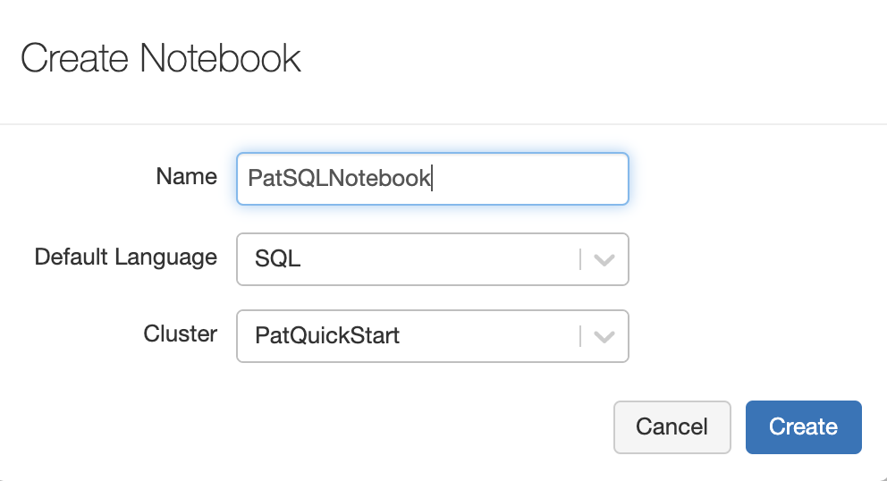

In the first cell of the Notebook you can run some basic Python code:

|  |
| --- |
| %python  print("Hello") |

## FileStore

FileStore is a special folder within the Databricks File System (DBFS) that is accessible to a web browser. This folder can be used to upload and download files to and from the DBFS. See <https://docs.databricks.com/data/filestore.html>

You can use FileStore to:

* Save files, such as images and libraries, that are accessible within HTML and JavaScript when you call displayHTML.
* Save output files that you want to download to your local desktop.
* Upload CSVs and other data files from your local desktop to process on Databricks.

### Uploading to FileStore

To upload data to the File Store, click the **Browse Files** link. Then navigate to your data file and upload it.



In this case, I uploaded a csv file called **truck.csv**. You can find the truck.csv file in **DBFS | FileStore | tables** area.





### Reading from File Store

Example : Reading from the File Store

This example shows how to use the Notebook at Databricks to mount and read a file from the File Store into a pandas DataFrame.

|  |
| --- |
| %python  # Copy file into mount.  dbutils.fs.cp("/FileStore/tables/truck.csv", "file:/tmp/truck.csv")  # Read from mounted file.  import pandas as pd  pandas_df = pd.read_csv("file:/tmp/truck.csv", header='infer')  print(pandas_df) |

### Listing Databricks Tables Directory Contents

Example : Viewing FileStore Contents

This example demonstrates how to view the tables directory with the dbutils.fs.ls() function.

|  |
| --- |
| %python  display(dbutils.fs.ls("/FileStore/tables/")) |

The output shows that a sample truck.csv file exists in the file store.

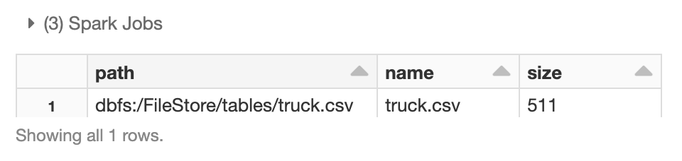

## Deleting Content from the File Store

To remove files from the FileStore run this command:

|  |
| --- |
| dbutils.fs.rm("/FileStore/tables/pat_diamonds2.json") |

Exercise (1 mark)

Modify the code in Example 3 to only show the folders that currently exist in the FileStore directory. Show the screenshot of the output here:

|  |
| --- |
|  |

## Databricks File System

The Databricks File System is referred to as DBFS.

### Listing and Reading Files in from the DBFS

Example : List and Read Files in Databricks File System

This example shows how to display directory contents and to read a file.

|  |
| --- |
| %python  # Take a look at the file system  display(**dbutils.fs.ls**("/databricks-datasets/samples/docs/")) |

We can see from the output that a file named README.md exists.

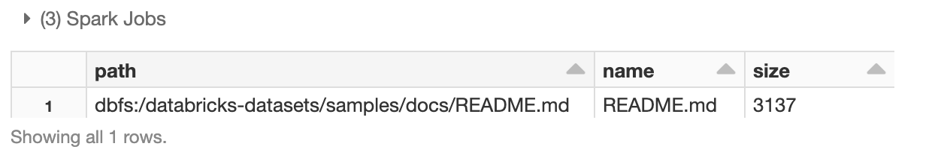

Note that the code below uses the Apache Spark dataframe API. The Spark context is created for us automatically when we create a Notebook in Databricks. The Spark context contains the connectivity we need to issue commands from our application to the executors in the cluster. For this case, the spark.read.text() instruction reads the README.md text file and creates a Spark dataframe named textFile.

|  |
| --- |
| %python  # Use spark session to read file into data frame.  textFile = spark.read.text("/databricks-datasets/samples/docs/README.md")  textFile.count()  # Show contents.  print(textFile.head(5))  print(textFile.tail(1)) |

The output shows the content.

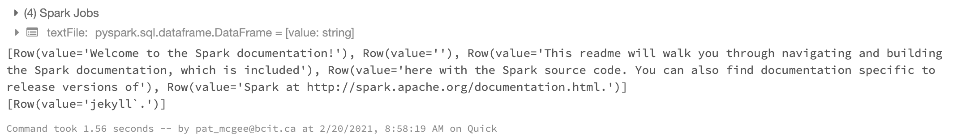

Exercise (6 marks)

Upload a text file to the FileStore that has “Hello world!” on the first line and your first name on the second line. Then, use PySpark to list the FileStore/tables directory contents after uploading the file. Then use PySpark read it and display the file contents. Your output should look like the following:

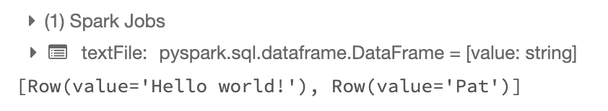

Show a screenshot of the FileStore/tables directory output after your file has been uploaded.

|  |
| --- |
|  |

Show your code here:

|  |
| --- |
|  |

Show a screenshot of your output with your first name in it here:

|  |
| --- |
|  |

### Querying the Databricks File System (DBFS) with SQL

It is possible to generate in-memory tables from data that exists in the Databricks file system (DBFS).

Example : Creating and Reading a Spark Table from a CSV File

In this example, starting with the Notebook created in Example 1, you will create a table from a sample CSV data file that exists in the Databricks sample datasets.

|  |
| --- |
| %sql  DROP TABLE IF EXISTS diamonds;  CREATE TABLE diamonds USING CSV OPTIONS (path "/databricks-datasets/Rdatasets/data-001/csv/ggplot2/diamonds.csv", header "true") |

In the next cell, add sql code to query the table.

|  |
| --- |
| %sql  SELECT color, avg(price) AS price FROM diamonds GROUP BY color ORDER BY COLOR |

Here is the output from the summary query.

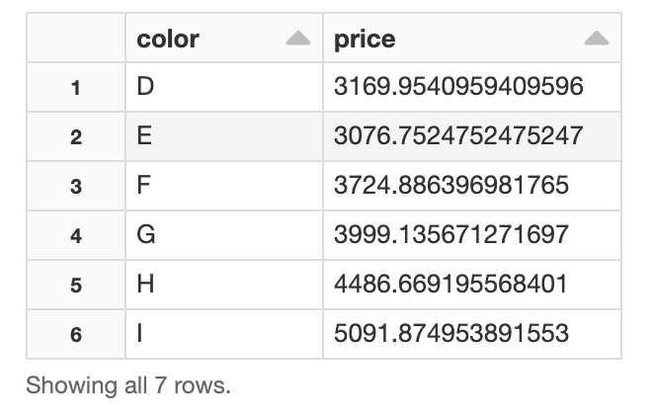

## Data Lakes

A data lake is a centralized repository that allows you to store all of your structured and unstructured data at any scale. You can store your data as-is, without having to first structure the data, and run different types of analytics.

### Delta Lake

Delta Lake with Databricks is a highly scalable open format storage layer that delivers reliability, security and performance on your data lake for both streaming and batch operations. In other words, the Delta Lake is a layer on top of the Data Lake. The Delta Lake provides an easier-to-use interface for managing and accessing the data in the lake.

### Delta Table

Delta tables provide a queryable format from content in the Delta Lake. Delta tables are accessible through both SQL and PySpark. Using Apache Spark or SQL code, you can change the storage format from parquet, csv, json, and so on, to delta which can then be queried.

Example : Creating and Reading from a Delta Table

This example uses PySpark to read data from a CSV file and store it to delta format.

|  |
| --- |
| %python  diamonds = spark.read.csv("/databricks-datasets/Rdatasets/data-001/csv/ggplot2/diamonds.csv", header="true", inferSchema="true")  diamonds.write.format("delta").mode("overwrite").save("/mnt/delta/diamonds2") |

This next cell implements SQL to read from the delta table.

|  |
| --- |
| %sql  SELECT * FROM delta.`/mnt/delta/diamonds2` |

We can also use PySpark to read the same delta table.

|  |
| --- |
| %python  events = spark.read.format("delta").load("/mnt/delta/diamonds2")  display(events) |

When reading the data using SQL or PySpark the output from the query is identical.

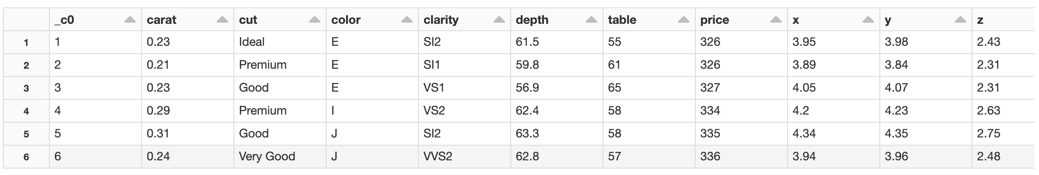

## Apache Spark Introduction

Apache Spark enables easier handling of data that is distributed across multiple machines. Apache Spark hides the details so you can mostly code as if all of the data is local when it really is distributed. This section will introduce Apache Spark syntax to give you an idea of what it looks like when manipulating data sets across multiple servers. Much of the time though you can avoid inspecting the different server nodes and proceed as if the data is local.

This next section explores basic commands for working with data across multiple servers with Apache Spark.

### Spark Context

Every Spark application uses a context to communicate with the other servers and to drive operations. The context is provided to us by default.

Figure : Cores Set Aside to Run Tasks

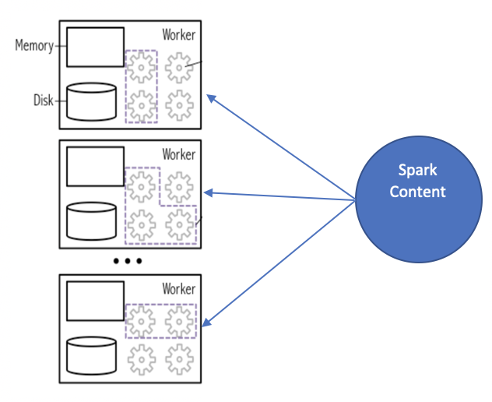

Example : Viewing the Spark Context

To view the context that already exists, in your notebook run the following command.

|  |
| --- |
| %python  # Display the type of the Spark Context sc.  type(sc)  print(sc) |

The output shows the reference to the Spark context.

PythonShellImpl.RemoteContext

<SparkContext master=local[8] appName=Databricks Shell>

## Resilient Distributed Datasets (RDDs)

Clustered data sets are referred to as **Resilient Distributed Datasets** (**RDDs**). Resilient Distributed Dataset (RDD) are immutable (unchangeable) when stored.

### Creating Data and Parallelizing Data

When storing data, it can be stored across partitions. Figure 2 shows three different workers processing the data set in parallel.

Figure : In-memory access to data which is stored across partitions.

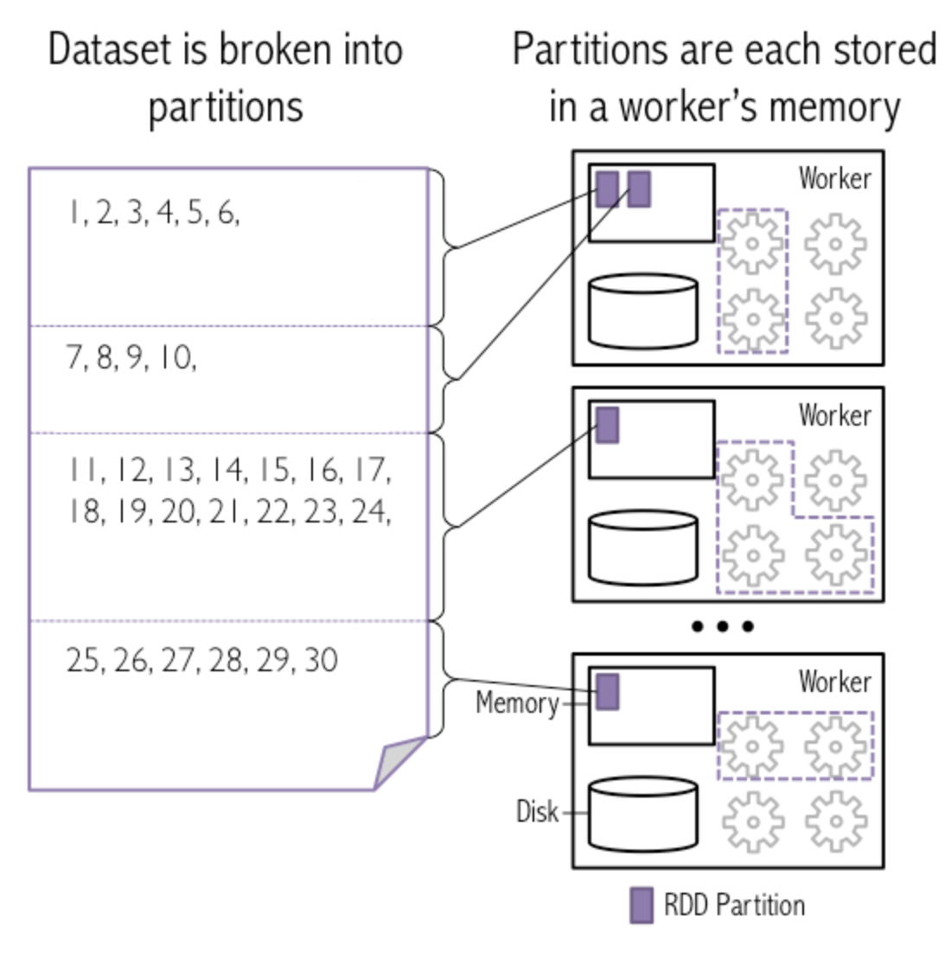

Example : Partitioning the Data

This example generates a data set of 10,000 numbers that range from 1 to 10,000. It then partitions the data across 7 partitions where each partition could be stored on a separate machine in our cluster. The collection of partitions is called a resilient distributed dataset (RDD).

|  |
| --- |
| %python  # Create the data from 1 to 10,000.  data = range(1,10001)  # print the first and last elements  lenData = len(data)  print("Length of dataset: " + str(lenData))  print("First number: " + str(data[0]))  print("Last number: " + str(data[lenData-1]))  # Parallelize data using 7 partitions  # This operation is a transformation of data into an RDD  # Spark uses lazy evaluation, so no Spark jobs are run at this point  xrangeRDD = sc.parallelize(data, 7) |

Each RDD gets a unique RDD. To show the id for the RDD created above, add this code in a cell below:

|  |
| --- |
| %python  # Each RDD gets a unique ID  print('xrangeRDD id: {0}'.format(xrangeRDD.id()))  # Observe the number of data partitions.  numPartition = xrangeRDD.getNumPartitions()  print("Num partitions: " + str(numPartition))  # We can name each newly created RDD using the setName() method  # xrangeRDD.setName('My first RDD')  xrangeRDD.setName('My first RDD') |

For this case, the RDD uses 7 partitions and has an id of 669. The setName() function renames the RDD to be “My first RDD”.

xrangeRDD id: 669

Num partitions: 7

Out[13]: My first RDD PythonRDD[669] at RDD at PythonRDD.scala:58

Example : Performing a Parallel Operation

This example shows how to implement operations in parallel across partitions. map() applies a function named *sub* to subtract 1 from all numbers stored across our RDD.

subRDD = xrangeRDD.map(sub)



After the parallel operation is finished, results from all partitions are pulled together with the instruction:

subRDD.collect()



This code performs the parallel operation described. The new dataset is stored in the variable *subRDD*. The *collect()* function gathers data from all partitions.

|  |
| --- |
| %python  # Perform parallel operations across partitions.  def sub(value):  return (value - 1)  subRDD = xrangeRDD.map(sub)  # Collect from partitions.  print(subRDD.collect()) |

The output shows the data after it has been operated on and collected.

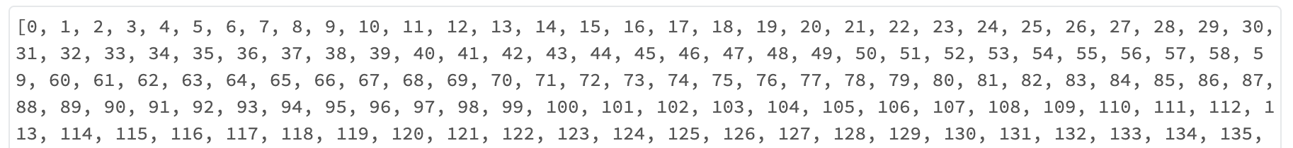

…

Exercise (2 marks)

In a Notebook cell below the cell from Example 9, write the code to print the id’s of both RDD’s. Show your instructions here:

|  |
| --- |
| %python  #exercise 3  # Print the ID of the xrangeRDD  print('xrangeRDD id: {0}'.format(xrangeRDD.id()))  # Print the ID of the subRDD  print('subRDD id: {0}'.format(subRDD.id())) |

Show the output from your print statements here:

|  |
| --- |
|  |

Exercise (2 marks)

Run the code which performs the parallel operation in Example 9 again. Then run the cell which prints out the id’s of both RDDs. Does the id of xrangeRDD change?

YES NO

Does the id of subRDD change?

YES NO

### filter()

Filter transformations filter existing data so no transformations are run.

Example : filter()

This example implements a custom filter() function so it only returns elements in the RDD that are less than 10.

|  |
| --- |
| %python  def lessThanTen(value):  if (value < 10):  return True  else:  return False  # Pass the function ten to the filter transformation  # Filter is a transformation so no tasks are run  filteredRDD = subRDD.filter(lessThanTen)  # View the results using collect()  # Collect is an action and triggers the filter transformation to run  print("\n*** Filtered RDD")  print(filteredRDD.collect()) |

The output shows only values from *subRDD* that are less than 10.



Exercise (2 marks)

Apply the lessThanTen function with a filter to xrangeRDD in addition to subRDD. Show the output.

|  |
| --- |
|  |

How is the output different than the output from filtering with subRDD?

|  |
| --- |
| 0 is not included |

### Lambda Functions

It is possible to implement anonymous functions like the one in Example 10 with a lambda function.

Example : lambda functions

This code performs the exact same operation as Example 10.

|  |
| --- |
| %python  lambdaRDD = subRDD.filter(lambda x: x < 10)  lambdaRDD.collect()  # View the results using collect()  # Collect is an action and triggers the filter transformation to run  print("\n*** lambda RDD")  print(lambdaRDD.collect()) |

The elements returned in this case are identical to the elements that are returned in Example 10.

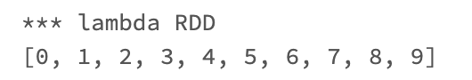

### PySpark Syntax

The operations in this section on RDD’s can actually be written condensed into one statement.

Example : PySpark Syntax

|  |
| --- |
| %python  subRDD = sc.parallelize(data,6)\  .map(lambda y: y - 1)\  .filter(lambda x: x < 10)\  .collect()  print(subRDD) |

The output from this code sample confirms that the same operations can be performed with the shorter notation.

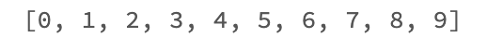

Exercise (8 marks)

Starting with the following data:

forecast = [14, 12, 11, 11, 12, 12, 12]

Write a PySpark statement that parallelizes the data over 4 partitions, converts the data elements to Fahrenheit and collects values that are greater than 53F. Show your code here:

|  |
| --- |
| %python  # exercise 6  # Define the forecast data  forecast = [14, 12, 11, 11, 12, 12, 12]  # Parallelize the forecast data into 4 partitions  rdd = spark.sparkContext.parallelize(forecast, 4)  # Convert the data elements to Fahrenheit (F = C * 9/5 + 32)  rdd_fahrenheit = rdd.map(lambda c: c * 9/5 + 32)  # Filter the data elements greater than 53F  rdd_greater_than_53 = rdd_fahrenheit.filter(lambda f: f > 53)  # Collect the filtered data  filtered_forecast = rdd_greater_than_53.collect()  # Print the filtered data  print(filtered_forecast) |

Show a screenshot of your output here:

|  |
| --- |
|  |

## Loading a Dataset into the File Store

Example : Loading a Dataset into the File Store

This example reviews steps from last session for loading content into the FileStore area. In this example though we will load the wine quality dataset into the FileStore area. To upload data to the File Store, click the **Browse Files** link. Then navigate to your data file and upload it.

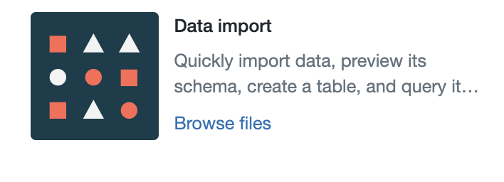

In this case, I uploaded a csv file called **winequality.csv**. You can find the truck.csv file in **DBFS | FileStore | tables** area. When finished, the **winequality.csv** file will be located in the **DBFS | FileStore | tables** area.



## Performing Linear Regression on a Resilient Distributed Dataset

Example : Performing Linear Regression on an RDD

This example discusses how to perform linear regression with the wine quality dataset that is loaded from the file store in Example 13.

|  |
| --- |
| %python  **# CELL A**  # Load wine quality dataset into Spark dataframe.  wineSparkDf = spark.read.csv("/FileStore/tables/winequality.csv",  header="true", inferSchema="true")  print("Original dataframe length: " + str(wineSparkDf.count()))  display(wineSparkDf.head(3)) |

Here is the Spark data frame contents after it has been loaded from the FileStore.

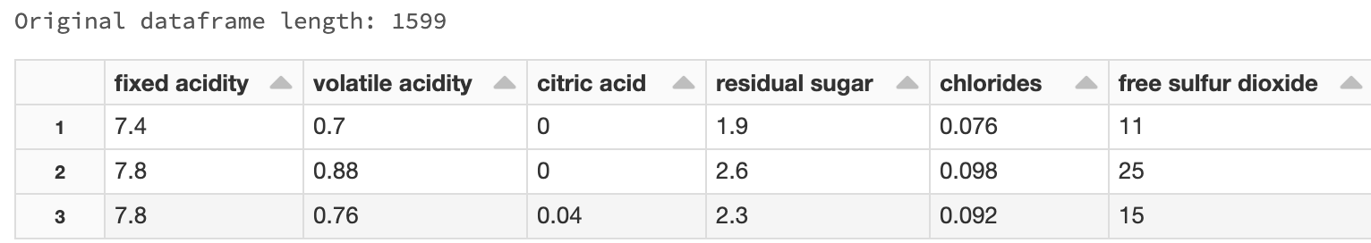

Cell B splits the Spark data frame into 4 partitions and shows statistics for each partition.

|  |
| --- |
| %python  **# CELL B**  # Convert Spark dataframe to RDD with 4 partitians.  wineRDD = wineSparkDf.rdd.repartition(4)  # Get partition statistics.  print("RDD num: " + str(wineRDD.id()))  print("Num particians: " + str(wineRDD.getNumPartitions()))  # Show each partition id and count.  from pyspark.sql.functions import spark_partition_id, asc, desc  wineRDD.toDF()\  .withColumn("partitionId", spark_partition_id())\  .groupBy("partitionId")\  .count()\  .orderBy(asc("count"))\  .show() |

The output displays the partition ids and row counts.

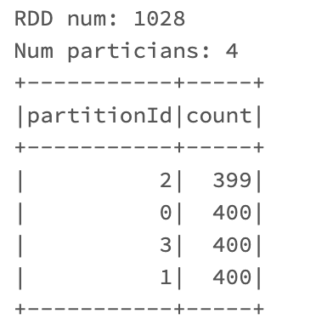

Exercise (1 mark)

Write down the total number of data frame rows that are displayed when running cell A. Indicate if the sum of the row counts for each partition displayed by cell B equals the total number of rows for the entire data frame that is displayed by the code from cell A.

|  |
| --- |
| When running cell A, 3 rows are displayed. The original dataframe length is 1599  When running cell B, the total of each row is equal to 1599, the same as cell A. |

To continue with Example 14, add the following cell which retrieves the data from the partitions into a Spark dataframe with the **toDF()** function.

|  |
| --- |
| %python  **# CELL C**  # Convert partitions back to Spark dataframe with the toDF() function.  df2 = wineRDD.toDF()  print("\nRetrieved dataframe length: " + str(df2.count()))  display(df2.head(3)) |

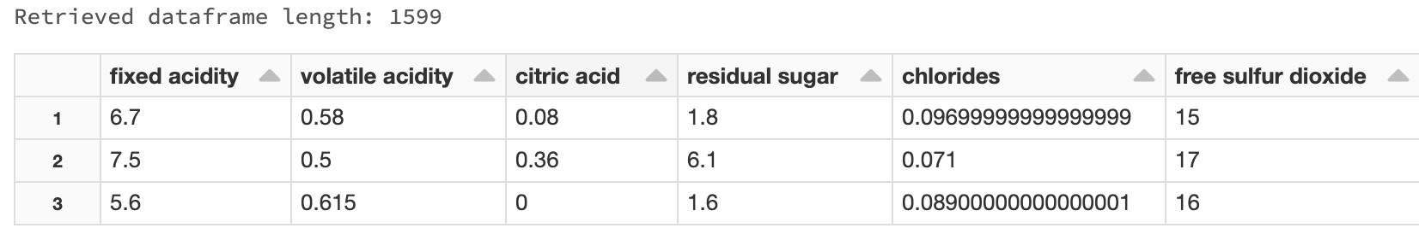

Exercise (1 mark)

Compare the dataframe lengths that are output from cell A before the data is partitioned and from cell C after the data is collected from the partitions. Are the lengths the same?

|  |
| --- |
| They are the same, 1599 |

Exercise (1 mark)

Compare the dataframe row sequence that is output from cell A before the data is partitioned and from cell C after the data is retrieved from the partitions. Is the sequence the same?

Yes No

Explain why.

|  |
| --- |
| When the toDF() function converts the partitions, it organizes the data rows differently. |

Next, the code for cell D prepares and fits our linear regression model. The attributes that are highlighted in yellow need to be adjusted depending on the dataset and model being developed. For a basic multivariate regression the rest of the code can remain the same. We will discuss the machine learning pipeline further next day. For now though, please note the three steps needed to configure the pipeline in this block of code:

|  |
| --- |
| %python  # CELL D  from pyspark.ml.regression import LinearRegression, LinearRegressionSummary  from pyspark.ml.feature import VectorAssembler  from pyspark.ml import Pipeline  # 1. Configure input columns here.  assembler = VectorAssembler(inputCols=['volatile acidity', 'chlorides',  'total sulfur dioxide', 'sulphates','alcohol'], outputCol="features")  # 2. Configure target column here.  lr = LinearRegression(labelCol="quality")  # 3. These are standard instructions for fitting the model.  # They do not need to change unless you want to adjust the  # train/test split.  pipeline = Pipeline(stages=[assembler, lr])  train, test = df2.randomSplit([0.75, 0.25])  model = pipeline.fit(train)  predictions = model.transform(test) |

Then, the cell E code uses the model from cell D to make predictions. The target variable may need to be adjusted depending on the model being developed.

|  |
| --- |
| %python  # CELL E  from pyspark.ml.evaluation import RegressionEvaluator  # Configure the 'quality' column here.  eval = RegressionEvaluator(labelCol="quality", predictionCol="prediction")  # Show the predictions.  # Note that the prediction column is added to the original data frame.  display(predictions.head(3))  # Show statistics for continuous regression.  print('RMSE:', eval.evaluate(predictions, {eval.metricName: "rmse"}))  print('R-squared:', eval.evaluate(predictions, {eval.metricName: "r2"})) |

The output shows the prediction columns, RMSE and $R^{2}$ values. Note that prediction columns are contained in the same Spark dataframe as the other wine attributes. Also note that even though the model was developed with a 'volatile acidity', 'chlorides',

'total sulfur dioxide', 'sulphates', alcohol' attributes, all original dataset attributes are present in the dataframe.

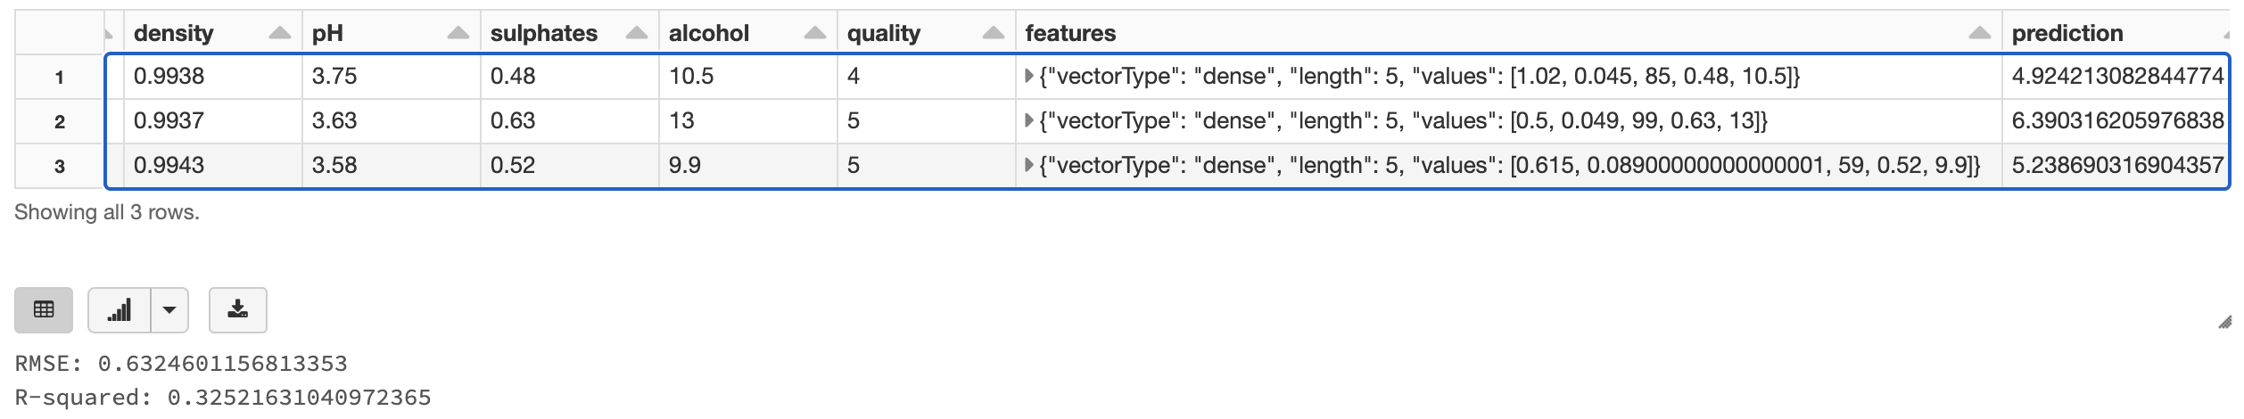

Exercise (1 mark)

Don’t over think this question. What is the header name of the column which stores the predicted values in the output from cell E?

|  |
| --- |
| prediction |

Exercise (8 marks)

Load the **USA_Housing.csv** file into the FileStore tables folder. Then, store the data into 3 different partitions. Obtain the partition ids and row counts for each of the partitions.

There is a problem that occurs when loading the USA_Housing.csv file into a Spark dataframe. Mystery rows are appearing on every second line. These rows never existed before. When dropping the mystery rows it was apparent that all values were read as strings. To fix these problems, include these extra parameters in the read.csv() function. Also rename the columns to remove spaes from the headers. Here is some starter code:

|  |
| --- |
| %python  # CELL A  # Load wine quality dataset into Spark dataframe.  houseSparkDf = spark.read.csv("/FileStore/tables/USA_Housing.csv", \  inferSchema=True, header=True, multiLine=True, escape='"');    houseSparkDf = houseSparkDf.withColumnRenamed("Avg. Area Income","avg_area_income")  houseSparkDf = houseSparkDf.withColumnRenamed("Avg. Area House Age","avg_house_age")  houseSparkDf = houseSparkDf.withColumnRenamed("Avg. Area Number of Rooms","avg_area_num_rooms")  houseSparkDf = houseSparkDf.withColumnRenamed("Avg. Area Number of Bedrooms","avg_area_number_of_br")  houseSparkDf = houseSparkDf.withColumnRenamed("Area Population", "area_population")    #houseSparkDf.printSchema()  print("Original dataframe length: " + str(houseSparkDf.count()))  display(houseSparkDf.head(10))  print(houseSparkDf.count())    # Verify that columns are in the correct format.  print(houseSparkDf.schema) |

Show a screenshot of the partition ids and row counts here:

|  |
| --- |
|  |

After, join the partitioned data with the toDF() function. Then, use the numeric attributes to create a linear regression model for the price column. After performing linear regression, calculate the RMSE and $R^{2}$ values. Show a screenshot which displays the dataframe which also contains the predictions from the linear regression model. Be sure to include the “prediction” column along with two or three other USA housing columns in the screenshot. Also include the RMSE and $R^{2}$ values in the screenshot. Show your screenshot here:

|  |
| --- |
|  |

## Storing and Retrieving Data from a Data Lake

A data lake is a centralized repository that allows you to store all of your structured and unstructured data at any scale. You can store your data as-is, without having to first structure the data, and run different types of analytics.

Example : Storing Data in a Data Lake and Then Using it in a Model

This example demonstrates how to store data in a data lake. The data is then retrieved from the data lake and is partitioned into different nodes. The data set is then modified with parallel processing. Then the data is retrieved for modeling after the parallel processing.

Starting with Example 14, replace the code in cell A with this version. Note that in order to store data in delta format the Spark dataframe column headers cannot contain spaces.

|  |
| --- |
| %python  # CELL A  # Load wine quality dataset into Spark dataframe.  wineDf = spark.read.csv("/FileStore/tables/winequality.csv",  header="true", inferSchema="true")  print("Original dataframe length: " + str(wineSparkDf.count()))  # Must rename columns to remove spaces before storing in data lake.  wineDf = wineDf.withColumnRenamed("fixed acidity","fixed_acidity")  wineDf = wineDf.withColumnRenamed("volatile acidity","volatile_acidity")  wineDf = wineDf.withColumnRenamed("citric acid","citric_acid")  wineDf = wineDf.withColumnRenamed("residual sugar","residual_sugar")  wineDf = wineDf.withColumnRenamed("free sulfur dioxide", "free_sulfur_dioxide")  wineDf = wineDf.withColumnRenamed("total sulfur dioxide", "total_sulfur_dioxide")  # Store data in the data lake.  wineDf.write.format("delta").save("/mnt/delta/winequality")  # Read data from the data lake.  wineSparkDf = spark.read.format("delta").load("/mnt/delta/winequality")  display(wineSparkDf) |

After running the code it is possible to view the data in the data lake. From the Databricks icon click **Import and Explore Data**.



Then, from the **DBFS** tab, choose **mnt | delta | winequality**. The data is stored in delta format.

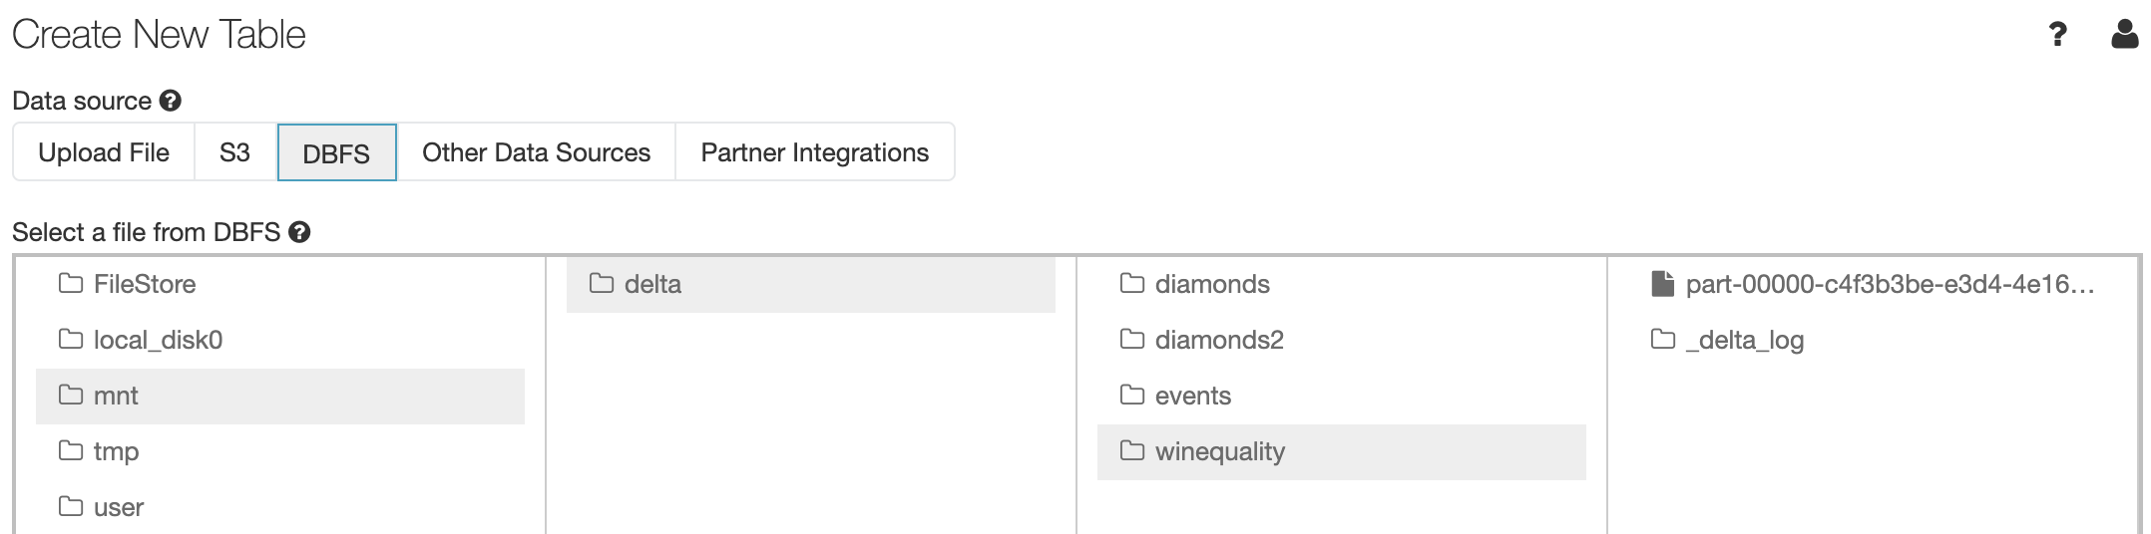

Exercise (1 mark)

Run the code for Example 15 twice. What error do you receive when running the code in cell A a second time? Why does this error occur?

|  |
| --- |
| The Error is:  AnalysisException: Cannot write to already existent path dbfs:/mnt/delta/winequality without setting OVERWRITE = 'true'.  There is an option for overwriting that is not enabled. |

## References

<https://databricks-prod-cloudfront.cloud.databricks.com/public/4027ec902e239c93eaaa8714f173bcfc/4538883350836412/3508262507098993/7991902709591605/latest.html>